# CSC8503

Screenshot shows the first level being played; this is a physics-based challenge featuring a tilting table that is controlled by the player via the arrow keys. It is created using a scene graph that allows children to be added to the floor of the level so that they tilt and stay connected to the floor as if it is one single object. It features multiple obstacles, including a rotating bouncy ball that the player ball must traverse, and then there is a rotating cube that knocks the player, and then there is a large ball attached to a cube above it like it is attached to a rope. It shifts depending on the floor tilt. Then there is a cube that moves up and down on state based logic. The blue section of the floor is icy and has less friction and less elasticity. The red section has high elasticity and high friction, and the ball can bounce on it. When the ball touches the green ball, the level is completed.

If the ball gets stuck or falls out of the level, F1 can be used to reset the level.

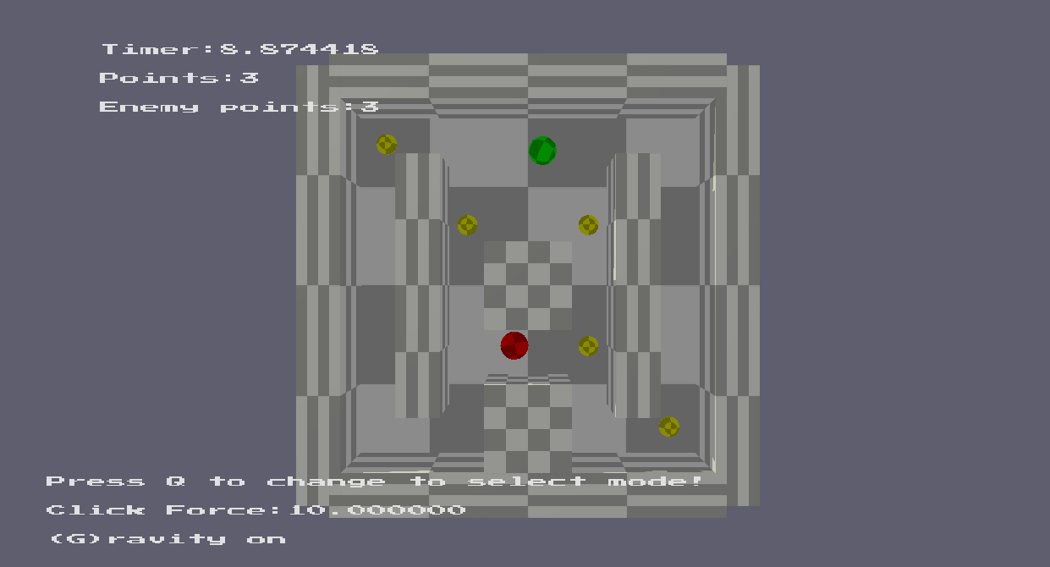

The second level is a maze in which an enemy and player ball spawn on opposite sides. The enemy ball has two states determined by a state machine. It either uses pathfinding to relocate to a point in the middle of the level or if the player ball is in a close enough range it will begin to chase the player. If the enemy or the player hit a yellow ball it gains a point shown by the counter at the top left. The game ends when either the player has come into contact with the enemy ball or all the yellow balls have been picked up. If the player hits the enemy he loses the game. To win the game all the balls must be picked up and then the amount of balls is compared, if the player has more they win, if the enemy has more the player loses.

After a game finishes it will take 10 seconds to reset. It can also be reset at any time using F2.

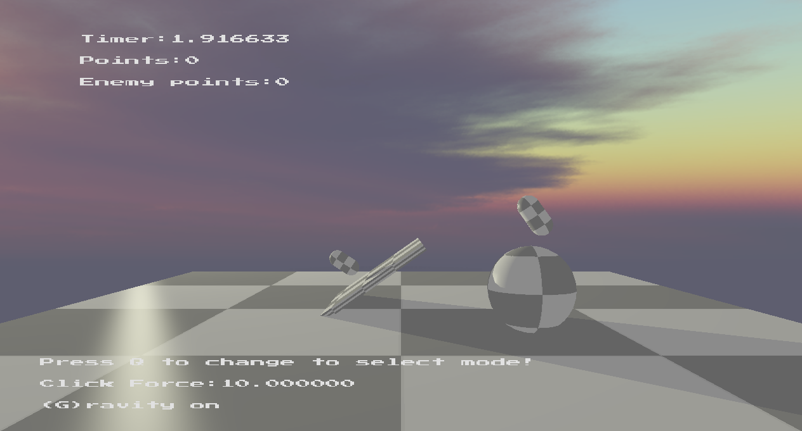

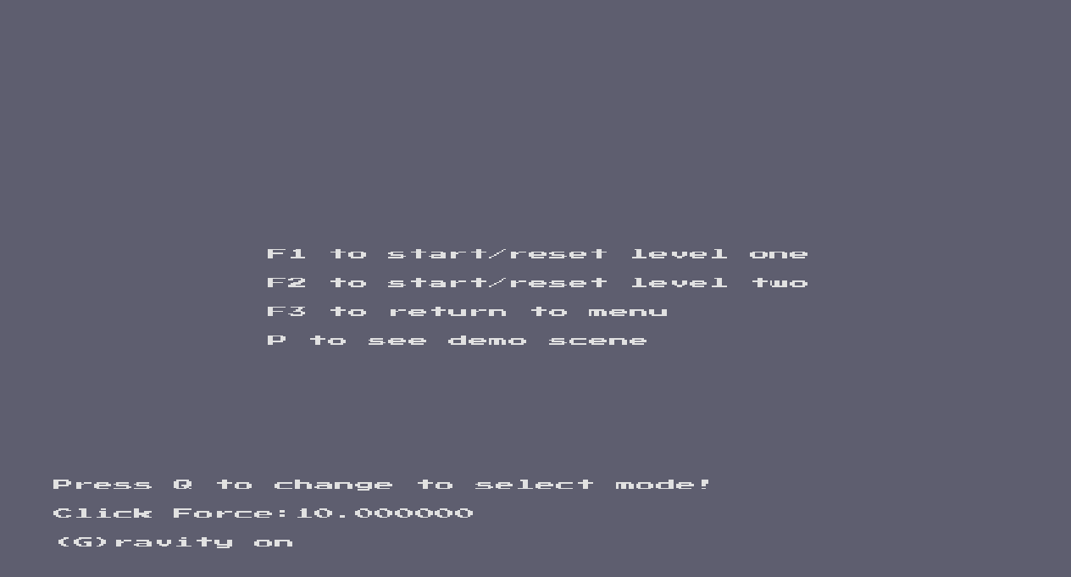By pressing P, you can access a demo scene which features capsules, a tilted OBB and a sphere, with an AABB floor. This is just to demonstrate capsule collisions which I had attempted.

This shows the simple menu that was implemented that is how the game starts out on launch and can be returned to by pressing F3. F1 starts the first level, and F2 starts the second. P accesses the demo scene. The menu can be returned to at any time but the player can also switch to a different level whilst in another with the same buttons.

# Controls

## Camera

W/A/S/D – Can freely move the camera around the scene.

Mouse movement – controls the pan of the camera.

Shift – Camera moves up.

Space – Camera moves down.

## Raycast mode

Q – activates debug/raycast mode. Objects can be clicked to show details about their position in the world. When selecting the enemy object in the second level it displays its current state.

Left click – Selects an object.

Right click – applies click force.

Scroll – Increases or decreases force applied on click.

## Game

Game 1:

Arrow keys – Tilts the floor in the corresponding direction

Game 2:

Arrow keys – Moves player ball in the corresponding direction.

## Other

G – Toggles gravity,

F1 – Start or reset level one.

F2 – Start or reset level two.

F3 – Return to menu.

P – Start or reset capsule demo.

B – Enables broadphase collisions.

**YouTube: https://youtu.be/SUcys9R-iVg**